# Selected topics in AI-2

# Assignment 1

|  |  |
| --- | --- |
| Name | ID |
| Marwan Mohamed abdelmonem | 20190513 |
| Youssef Hesham Mohamed | 20190648 |

In this report we have constructed a classification model using active learning strategies applied on three datasets, two datasets are normally distributed while the third is unbalanced.

First, we'll give a brief regarding the datasets and the strategies used then we advance to the analysis and the information extracted from these scenarios.

## Dataset brief

1. Iris dataset: It consists of 150 samples of iris flowers, each containing measurements of the sepal length, sepal width, petal length, and petal width. The goal is to classify each sample into one of three species: setosa, versicolor, or virginica, based on the four measurements.
2. Mushroom datasets: This dataset includes descriptions of hypothetical 8124 samples corresponding to 23 species of gilled mushrooms in the Agaricus and Lepiota Family Mushroom drawn from The Audubon Society Field Guide to North American Mushrooms (1981). Each species is identified as definitely edible, definitely poisonous, or of unknown edibility and not recommended. This latter class was combined with the poisonous one. The Guide clearly states that there is no simple rule for determining the edibility of a mushroom; no rule like "leaflets three, let it be'' for Poisonous Oak and Ivy.
3. Stroke Prediction Dataset: This dataset is used to predict whether a patient is likely to get stroke based on the input parameters like gender, age, various diseases, and smoking status. Each row in the data provides relevant information about the patient. Contains 5110 observations with 12 attributes.

Attribute Information

1) id: unique identifier

2) gender: "Male", "Female" or "Other"

3) age: age of the patient

4) hypertension: 0 if the patient doesn't have hypertension, 1 if the patient has hypertension

5) heart_disease: 0 if the patient doesn't have any heart diseases, 1 if the patient has a heart disease

6) ever_married: "No" or "Yes"

7) work_type: "children", "Govt_jov", "Never_worked", "Private" or "Self-employed"

8) Residence_type: "Rural" or "Urban"

9) avg_glucose_level: average glucose level in blood

10) bmi: body mass index

11) smoking_status: "formerly smoked", "never smoked", "smokes" or "Unknown"*

12) stroke: 1 if the patient had a stroke or 0 if not

Next, we discuss the four query strategies that were used.

## Query strategies

1. Uncertainty Sampling: This strategy selects the instances where the model is most uncertain about the predicted class label. The query strategy queries the instances for which the classifier is least confident. In the code, it is implemented by selecting the samples with the least confidence score as measured by the maximum probability of the predicted class. This strategy helps to maximize the model's accuracy by focusing on the most informative samples.
2. Entropy Sampling: This strategy measures the uncertainty of the predicted probability distribution of the classes. In other words, the query strategy chooses samples for which the model is most uncertain about the predicted probability distribution of the classes. In the code, it is implemented by selecting the samples with the highest entropy as measured by the predicted probability distribution. This strategy is useful when the model has low confidence or exhibits poor performance, but the samples it identifies are diverse and can help to better understand the data.
3. Random Sampling: This strategy selects the samples randomly from the unlabeled dataset, without any bias towards the informative samples. In the code, it is implemented by randomly selecting an instance from the pool of unlabeled samples. This strategy is useful when the dataset is uniformly distributed and there is no specific structure or pattern in the data.
4. Margin Sampling: This strategy selects the samples based on the difference in the probability of the predicted classes. The query strategy chooses samples for which the difference in the probability of the predicted classes is the smallest. In the code, it is implemented by selecting the samples with the smallest margin as measured by the predicted probability difference. This strategy is useful when the model has high accuracy and exhibits a high degree of confidence, but the samples it identifies are biased towards the most informative samples.

Now onto the analysis of the experiment,

## Iris Analysis

We picked three random samples from dataset as initialized dataset (trained with 4,5 and few more and found that 3 samples are the threshold for achieving low but improvable accuracy) then conducted a pool-based sampling approach for training and KNN model for prediction. The model achieved 0.333 without active learning after applying it here are the results.

1. Uncertainty sampling

Accuracy after query 1: 0.6667

Accuracy after query 2: 0.6667

Accuracy after query 3: 0.8800

Accuracy after query 4: 0.8800

Accuracy after query 5: 0.8733

Accuracy after query 6: 0.8400

Accuracy after query 7: 0.7400

Accuracy after query 8: 0.7267

Accuracy after query 9: 0.7267

Accuracy after query 10: 0.7267

Accuracy after query 11: 0.7267

Accuracy after query 12: 0.7267

Accuracy after query 13: 0.7267

Accuracy after query 14: 0.7267

Accuracy after query 15: 0.7200

Accuracy after query 16: 0.8400

Accuracy after query 17: 0.8800

Accuracy after query 18: 0.8933

Accuracy after query 19: 0.9267

Accuracy after query 20: 0.9267

Accuracy after query 21: 0.9267

Accuracy after query 22: 0.9067

Accuracy after query 23: 0.9400

Accuracy after query 24: 0.9467

Accuracy after query 25: 0.9467

Accuracy after query 26: 0.9467

Accuracy after query 27: 0.9467

Accuracy after query 28: 0.9467

Accuracy after query 29: 0.9667

Accuracy after query 30: 0.9733

1. random sampling

we used 25 queries instead of 30 as the first because it worsens after this number and this is the best strategy in terms of final acc

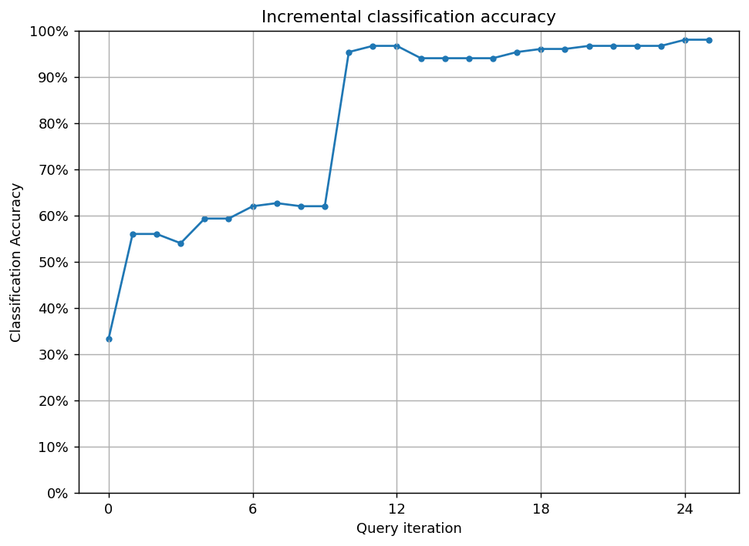Accuracy after query 1: 0.5600

Accuracy after query 2: 0.5600

Accuracy after query 3: 0.5400

Accuracy after query 4: 0.5933

Accuracy after query 5: 0.5933

Accuracy after query 6: 0.6200

Accuracy after query 7: 0.6267

Accuracy after query 8: 0.6200

Accuracy after query 9: 0.6200

Accuracy after query 10: 0.9533

Accuracy after query 11: 0.9667

Accuracy after query 12: 0.9667

Accuracy after query 13: 0.9400

Accuracy after query 14: 0.9400

Accuracy after query 15: 0.9400

Accuracy after query 16: 0.9400

Accuracy after query 17: 0.9533

Accuracy after query 18: 0.9600

Accuracy after query 19: 0.9600

Accuracy after query 20: 0.9667

Accuracy after query 21: 0.9667

Accuracy after query 22: 0.9667

Accuracy after query 23: 0.9667

Accuracy after query 24: 0.9800

Accuracy after query 25: 0.9800

1. entropy sampling

Accuracy after query 1: 0.6667

Accuracy after query 2: 0.6667

Accuracy after query 3: 0.8800

Accuracy after query 4: 0.8800

Accuracy after query 5: 0.8733

Accuracy after query 6: 0.8400

Accuracy after query 7: 0.7400

Accuracy after query 8: 0.7267

Accuracy after query 9: 0.7267

Accuracy after query 10: 0.7267

Accuracy after query 11: 0.7267

Accuracy after query 12: 0.7267

Accuracy after query 13: 0.7267

Accuracy after query 14: 0.7267

Accuracy after query 15: 0.7200

Accuracy after query 16: 0.8400

Accuracy after query 17: 0.8800

Accuracy after query 18: 0.8933

Accuracy after query 19: 0.9267

Accuracy after query 20: 0.9267

Accuracy after query 21: 0.9267

Accuracy after query 22: 0.9067

Accuracy after query 23: 0.9400

Accuracy after query 24: 0.9467

Accuracy after query 25: 0.9467

Accuracy after query 26: 0.9467

Accuracy after query 27: 0.9467

Accuracy after query 28: 0.9467

Accuracy after query 29: 0.9667

Accuracy after query 30: 0.9733

1. margin sampling

Accuracy after query 1: 0.6667

Accuracy after query 2: 0.6667

Accuracy after query 3: 0.8800

Accuracy after query 4: 0.8800

Accuracy after query 5: 0.8733

Accuracy after query 6: 0.8400

Accuracy after query 7: 0.7400

Accuracy after query 8: 0.7267

Accuracy after query 9: 0.7267

Accuracy after query 10: 0.7267

Accuracy after query 11: 0.7267

Accuracy after query 12: 0.7267

Accuracy after query 13: 0.7267

Accuracy after query 14: 0.7267

Accuracy after query 15: 0.7200

Accuracy after query 16: 0.8400

Accuracy after query 17: 0.8800

Accuracy after query 18: 0.8933

Accuracy after query 19: 0.9267

Accuracy after query 20: 0.9267

Accuracy after query 21: 0.9267

Accuracy after query 22: 0.9067

Accuracy after query 23: 0.9400

Accuracy after query 24: 0.9467

Accuracy after query 25: 0.9467

Accuracy after query 26: 0.9467

Accuracy after query 27: 0.9467

Accuracy after query 28: 0.9467

Accuracy after query 29: 0.9667

Accuracy after query 30: 0.9733

From these results and based on the initial setup we had to ensure that all strategies are applied within the same environment we found out that random sampling achieved the best accuracies while the other 3 strategies resulted in almost identical results and this conclude that small datasets will not have high impact in the aspect of selecting which strategy to compute but overall active learning will reduce the cost of samples and the computation power with higher accuracy than the normal model

## Mushrooms dataset

We picked 5 random samples from dataset as initialized dataset (trained with few more and found that 5 samples are the threshold for achieving low but improvable accuracy) then conducted a pool-based sampling approach for training and Decision Tree Classifier for prediction. The model achieved 0.562 without active learning after applying it here are the results.

1. Uncertainty sampling

We used 16 queries as more will result in a plateau.

Accuracy after query 1: 0.5623

Accuracy after query 2: 0.7563

Accuracy after query 3: 0.8981

Accuracy after query 4: 0.7784

Accuracy after query 5: 0.9557

Accuracy after query 6: 0.7784

Accuracy after query 7: 0.9202

Accuracy after query 8: 0.9557

Accuracy after query 9: 0.9557

Accuracy after query 10: 0.9557

Accuracy after query 11: 0.8981

Accuracy after query 12: 0.7784

Accuracy after query 13: 0.7784

Accuracy after query 14: 0.9557

Accuracy after query 15: 0.9557

Accuracy after query 16: 0.9852

1. random sampling

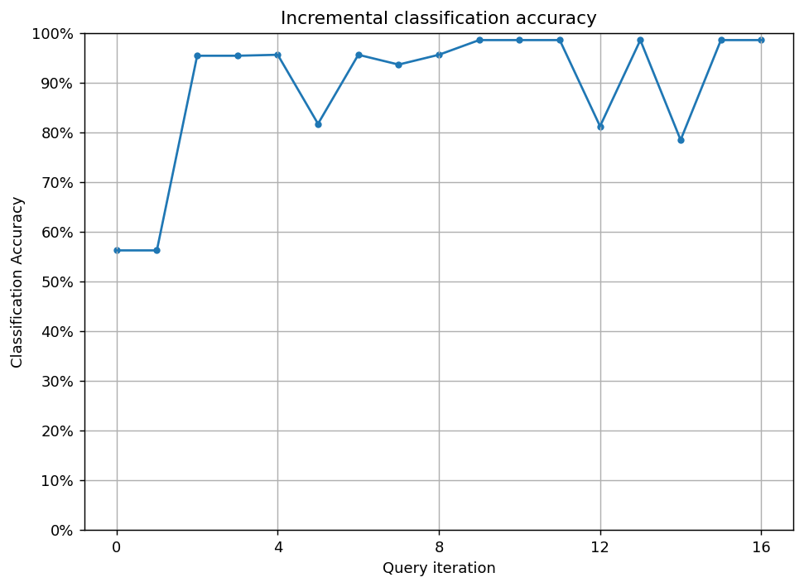Accuracy after query 1: 0.5623

Accuracy after query 2: 0.9537

Accuracy after query 3: 0.9537

Accuracy after query 4: 0.9557

Accuracy after query 5: 0.8168

Accuracy after query 6: 0.9557

Accuracy after query 7: 0.9360

Accuracy after query 8: 0.9557

Accuracy after query 9: 0.9852

Accuracy after query 10: 0.9852

Accuracy after query 11: 0.9852

Accuracy after query 12: 0.8119

Accuracy after query 13: 0.9852

Accuracy after query 14: 0.7843

Accuracy after query 15: 0.9852

Accuracy after query 16: 0.9852

1. 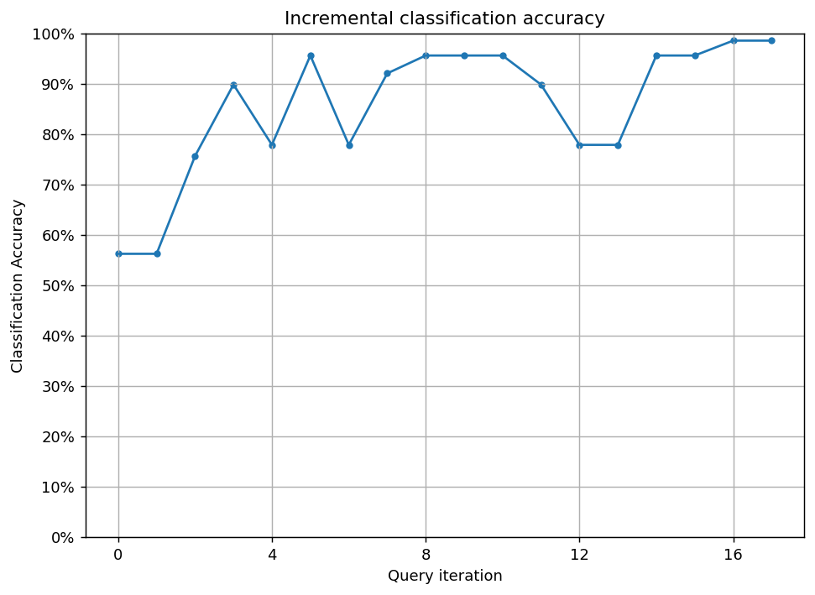entropy sampling

Accuracy after query 1: 0.5623

Accuracy after query 2: 0.7563

Accuracy after query 3: 0.8981

Accuracy after query 4: 0.7784

Accuracy after query 5: 0.9557

Accuracy after query 6: 0.7784

Accuracy after query 7: 0.9202

Accuracy after query 8: 0.9557

Accuracy after query 9: 0.9557

Accuracy after query 10: 0.9557

Accuracy after query 11: 0.8981

Accuracy after query 12: 0.7784

Accuracy after query 13: 0.7784

Accuracy after query 14: 0.9557

Accuracy after query 15: 0.9557

Accuracy after query 16: 0.9852

Accuracy after query 17: 0.9852

1. Chart, line chart

   Description automatically generatedmargin sampling

Accuracy after query 1: 0.5623

Accuracy after query 2: 0.7563

Accuracy after query 3: 0.8981

Accuracy after query 4: 0.7784

Accuracy after query 5: 0.9557

Accuracy after query 6: 0.7784

Accuracy after query 7: 0.9202

Accuracy after query 8: 0.9557

Accuracy after query 9: 0.9557

Accuracy after query 10: 0.9557

Accuracy after query 11: 0.8981

Accuracy after query 12: 0.7784

Accuracy after query 13: 0.7784

Accuracy after query 14: 0.9557

Accuracy after query 15: 0.9557

Accuracy after query 16: 0.9852

Accuracy after query 17: 0.9852

## Stroke Prediction dataset

The distribution of data:

Where '0' class is non-patient while '1' class is patient.

We picked 10 random samples from dataset as initialized dataset (trained with few more and found that 10 samples are the threshold for achieving low but improvable accuracy) then conducted a pool-based sampling approach for training and XGB Classifier for prediction. The model achieved f1 score with 0.19 without active learning after applying it here are the results.

1. Uncertainty sampling:

f1_score after query 1: 0.1889

Accuracy after query 1: 0.8723

f1_score after query 101: 0.1161

Accuracy after query 101: 0.3551

f1_score after query 201: 0.1161

Accuracy after query 201: 0.3551

f1_score after query 301: 0.1443

Accuracy after query 301: 0.4997

f1_score after query 401: 0.1474

Accuracy after query 401: 0.5264

f1_score after query 501: 0.1474

Accuracy after query 501: 0.5264

f1_score after query 601: 0.1637

Accuracy after query 601: 0.6003

f1_score after query 701: 0.1793

Accuracy after query 701: 0.6549

f1_score after query 801: 0.2069

Accuracy after query 801: 0.7299

f1_score after query 901: 0.2230

Accuracy after query 901: 0.7629

f1_score after query 1001: 0.2460

Accuracy after query 1001: 0.8002

f1_score after query 1101: 0.2889

Accuracy after query 1101: 0.8586

Accuracy after query 1201: 0.9004

f1_score after query 1301: 0.3874

Accuracy after query 1301: 0.9246

f1_score after query 1401: 0.4092

Accuracy after query 1401: 0.9318

f1_score after query 1501: 0.4684

Accuracy after query 1501: 0.9487

f1_score after query 1601: 0.4632

Accuracy after query 1601: 0.9481

f1_score after query 1701: 0.4540

Accuracy after query 1701: 0.9481

f1_score after query 1801: 0.4397

Accuracy after query 1801: 0.9470

f1_score after query 1901: 0.4236

Accuracy after query 1901: 0.9462

f1_score after query 2000: 0.4952

Accuracy after query 2000: 0.9572

1. random sampling

f1_score after query 1: 0.1889

Accuracy after query 1: 0.8723

f1_score after query 101: 0.0474

Accuracy after query 101: 0.9509

f1_score after query 201: 0.0806

Accuracy after query 201: 0.9489

f1_score after query 301: 0.1338

Accuracy after query 301: 0.9446

f1_score after query 401: 0.2102

Accuracy after query 401: 0.9434

f1_score after query 501: 0.2118

Accuracy after query 501: 0.9454

f1_score after query 601: 0.2435

Accuracy after query 601: 0.9468

f1_score after query 701: 0.2377

Accuracy after query 701: 0.9464

f1_score after query 801: 0.2507

Accuracy after query 801: 0.9464

f1_score after query 901: 0.2667

Accuracy after query 901: 0.9507

f1_score after query 1001: 0.2711

Accuracy after query 1001: 0.9507

f1_score after query 1101: 0.2857

Accuracy after query 1101: 0.9481

f1_score after query 1201: 0.2808

Accuracy after query 1201: 0.9489

f1_score after query 1301: 0.3208

Accuracy after query 1301: 0.9448

f1_score after query 1401: 0.3187

Accuracy after query 1401: 0.9495

f1_score after query 1501: 0.3220

Accuracy after query 1501: 0.9511

f1_score after query 1601: 0.3294

Accuracy after query 1601: 0.9536

f1_score after query 1701: 0.3226

Accuracy after query 1701: 0.9487

f1_score after query 1801: 0.3438

Accuracy after query 1801: 0.9534

f1_score after query 1901: 0.3788

Accuracy after query 1901: 0.9546

f1_score after query 2000: 0.3739

Accuracy after query 2000: 0.9550

1. entropy sampling

f1_score after query 1: 0.1889

Accuracy after query 1: 0.8723

f1_score after query 101: 0.1161

Accuracy after query 101: 0.3551

f1_score after query 201: 0.1161

Accuracy after query 201: 0.3551

f1_score after query 301: 0.1443

Accuracy after query 301: 0.4997

f1_score after query 401: 0.1474

Accuracy after query 401: 0.5264

f1_score after query 501: 0.1474

Accuracy after query 501: 0.5264

f1_score after query 601: 0.1637

Accuracy after query 601: 0.6003

f1_score after query 701: 0.1793

Accuracy after query 701: 0.6549

f1_score after query 801: 0.2069

Accuracy after query 801: 0.7299

f1_score after query 901: 0.2230

Accuracy after query 901: 0.7629

f1_score after query 1001: 0.2460

Accuracy after query 1001: 0.8002

f1_score after query 1101: 0.2889

Accuracy after query 1101: 0.8586

f1_score after query 1201: 0.3365

Accuracy after query 1201: 0.9004

f1_score after query 1301: 0.3874

f1_score after query 1401: 0.4092

Accuracy after query 1401: 0.9318

f1_score after query 1501: 0.4684

Accuracy after query 1501: 0.9487

f1_score after query 1601: 0.4632

Accuracy after query 1601: 0.9481

f1_score after query 1701: 0.4540

Accuracy after query 1701: 0.9481

f1_score after query 1801: 0.4397

Accuracy after query 1801: 0.9470

f1_score after query 1901: 0.4236

Accuracy after query 1901: 0.9462

f1_score after query 2000: 0.4952

Accuracy after query 2000: 0.9572

1. margin sampling

f1_score after query 1: 0.1889

Accuracy after query 1: 0.8723

f1_score after query 101: 0.1161

Accuracy after query 101: 0.3551

f1_score after query 201: 0.1161

Accuracy after query 201: 0.3551

f1_score after query 301: 0.1443

Accuracy after query 301: 0.4997

f1_score after query 401: 0.1474

Accuracy after query 401: 0.5264

f1_score after query 501: 0.1474

Accuracy after query 501: 0.5264

f1_score after query 601: 0.1637

Accuracy after query 601: 0.6003

f1_score after query 701: 0.1793

Accuracy after query 701: 0.6549

f1_score after query 801: 0.2069

Accuracy after query 801: 0.7299

f1_score after query 901: 0.2230

Accuracy after query 901: 0.7629

f1_score after query 1001: 0.2460

Accuracy after query 1001: 0.8002

f1_score after query 1101: 0.2889

Accuracy after query 1101: 0.8586

f1_score after query 1201: 0.3365

Accuracy after query 1201: 0.9004

f1_score after query 1301: 0.3874

Accuracy after query 1301: 0.9246

f1_score after query 1401: 0.4092

Accuracy after query 1401: 0.9318

f1_score after query 1501: 0.4684

Accuracy after query 1501: 0.9487

f1_score after query 1601: 0.4632

Accuracy after query 1601: 0.9481

f1_score after query 1701: 0.4540

Accuracy after query 1701: 0.9481

f1_score after query 1801: 0.4397

Accuracy after query 1801: 0.9470

f1_score after query 1901: 0.4236

Accuracy after query 1901: 0.9462

f1_score after query 2000: 0.4952

Accuracy after query 2000: 0.9572

## Conclusion

Each strategy in the uncertainty family doesn’t vary much as we can't for sure say that one strategy is better than other overall however the active learning approaches as a whole is better in the factors of maintaining high score in evaluation metrics (accuracy in most cases)

While reducing cost of computation, annotation and budget as we can run many models with many varieties in environment in parallel.